Kinematics 1D Quest Multiple Choice Questions

1. The area under a velocity-time graph represents
a. | displacement | d. | instantaneous velocity
b. | acceleration | e. | average velocity
c. | change in velocity

2. Which of the following graph(s) does(do) NOT represent uniform motion?
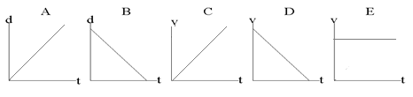

a. | A,B,C and D | d. | A and B
b. | B only | e. | C and D
c. | E only

3. The slope of a line drawn tangent to a curved position-time graph represents
a. | displacement | d. | acceleration
b. | instantaneous velocity | e. | distance
c. | average velocity

4. Which of the following are VECTOR quantities?
I. position II. speed III. displacement IV. velocity
a. I and III only d. II, III and IV only
b. III and IV only e. I, III and IV only
c. I and IV only

5. Two hikers set out from the same spot and arrive at the same destination but they take different routes. Which of the following quantities must be the same for both hikers?
a. | displacement | d. | average speed
b. | distance | e. | acceleration
c. | average velocity

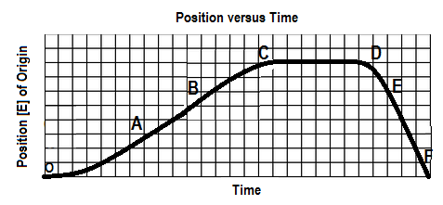
6. The graph below shows a position-time graph

Over which interval is the object moving west and speeding up?
a. OA b. BC c.CD d. DE e.EF

7. The graph at right shows the velocity-time graph for an object moving
in a straight line. Which of the graphs below is the corresponding
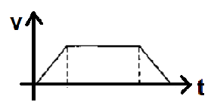
position-time graph?

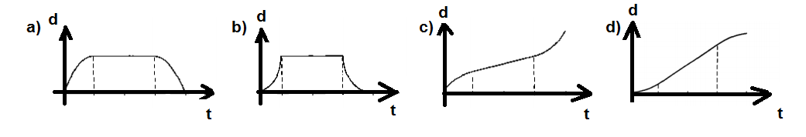

8. An object is travelling west and slowing down. The directions associated with the
object’s velocity and acceleration, respectively, are:
a. [W], [W] b. [W], [S] c. [W], [N] d. [E], [W] e. [W], [E]

SPH4U0-Feb. 2019 Kinematics Review Quest- Name:_________________

Total: _________/39 marks [K/U]
Useful Equations:
v_{av} =ΔΔ a =ΔΔ = Δ Δd= ½ (v₁+v₂) Δt Δd=v₂ Δt – ½ a (Δt)²

Δd=v₁ Δt + ½ a (Δt)² Δd = $\frac{v22-v12}{2a}$

Part A: Multiple Choice Answers [ 8 marks]:
Write the letter representing the best answer for each question in the table below:
1 | 2 | 3 | 4 | 5 | 6 | 7 | 8

Part B: Short Answer and Problem Solving [ 30 marks] + 1 mark Sig Digs:

- A delivery truck travels 5.0 km [North] in a time of 15.0 minutes and then 7.0 km [South] in 25.0 minutes. What is the truck’s average velocity and average speed? [4]

- A hockey puck is sliding at 12.0 m/s [Forward] when it hits a rough patch of ice. If it accelerates at a rate of 1.25 m/s²[Backward], find the puck’s velocity and displacement after 8.00 seconds. [5]

3.
- A sprinter competing in the Indoor Track and Field Championships accelerates from rest at 2.50 m/s² over the first 40.0 m of the race. He then runs the remaining 60.0 m of the race at his top speed.
Sketch position- time and velocity-time graphs for the sprinter on the axes provided. Make sure to label your graphs! [2]

v [forward]
d [forward]

- Find the sprinter’s top velocity at the end of his acceleration phase. [3]

- Find the total time for him to run the race! [3]

4.Two runners, Mickey and Goofy are playing a game of tag. Goofy is standing still when Mickey runs past him at a constant speed of 4.00 m/s. As soon as Mickey passes Goofy, Goofy accelerates from rest at a rate of 1.75 m/s². Find the time it takes Goofy to catch Mickey and how far he has to run to catch Mickey. [5]

_____/ 1 mark Sig Digs
Part C: Graph Analysis [8 marks]

- The motion of a train engine moving along a straight track in a railyard is shown on the
velocity-time graph below.
i) Draw the corresponding acceleration-tine graph for the train. [3]
ii) Assuming that the train starts at the station (origin), draw the corresponding
position-time graph. [5]

Position-Time Graph:

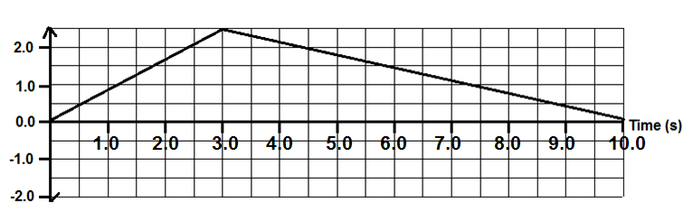
Velocity-Time Graph:


Acceleration-Time Graph:

